Chapter 1
Using Manning’s styles in your chapters
Updated 11/1/07
To simplify translation of your text from Word to typesetting, Manning uses a limited set of styles available on the Manning style toolbar (see figure 1.1). This toolbar should open automatically when you create a new document with the Manning template. If it doesn’t, choose View > Toolbars > Manning.
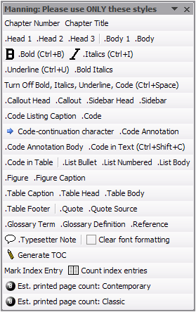
Figure 1.1 The Manning toolbar. If it isn't visible in your document, choose View > Toolbars > Manning.
The first regular paragraph in every chapter and after every heading should use the .Body 1 style, which isn’t indented. All other text paragraphs use the .Body style. To apply the correct styles to your content, select a paragraph and select a style from the Style drop-down menu located on the Formatting toolbar. Or, choose Format > Styles and Formatting to open the list of available styles, and select a style there.
tip [.Callout Head style]
The Manning template is protected, meaning that you can’t add styles or formatting that aren’t already part of the template. If for some reason you need a type of formatting that isn’t available, please speak to your editor, or insert a note using the .Typesetter Note style, explaining what you want. (And, by the way, this is a callout—a short side note. You can use three kinds of callouts: Tip, Note, and Warning. Use the .Callout Head style to indicate the type of callout and the .Callout style for the text.)
The rest of this sampler shows you what styles you should use in your chapters.
1.1 Using the .Head 1 style
The main sections of your chapter are set off using .Head 1 headings. You need to manually insert a section number like the one shown here.
1.1.1 Using the .Head 2 style
Use the .Head 2 subhead style when you have a large .Head 1 section that you want to break into smaller sections. Again, you need to manually insert a section number.
Note
All chapter titles and headings use sentence-style capitalization—the first word is capitalized, but the rest of the words are lowercase (unless, of course, they’re proper nouns).
Using the .Head 3 style
Use the .Head 3 subhead style when you wish to break a .Head 2 section into additional parts. These section headings aren’t numbered. Manning uses only three levels of headings; if you need to nest deeper than this, please reconsider your chapter organization.
1.2 Taking charge of list styles
You can create two kinds of lists: bulleted and numbered. Every list needs a lead-in sentence. Here are some sample bullets:
- This is a bulleted list.
- It uses the .List Bullet style.
- Word inserts the bullet character automatically.
Numbered lists use the .List Numbered style. The follow list illustrates how to create numbered steps:
- This style is used for numbered steps in procedures and processes you want the reader to follow.
- Word inserts the numbers automatically.
If you start a new list later in the document, you’ll need to put your insertion point in the list, right-click, and choose Restart Numbering from the context menu to begin your new list with step 1.
Note that this text, which continues a numbered (or bulleted) list item in a new paragraph, uses the .List Body style.
Be sure to end every section with .Body text. A section should never end with a list item, code, or a figure.
1.3 Entering code
Code text uses different styles, depending on where it appears. When you want to include a snippet of code or a few lines in their own paragraphs, use the .Code style, as follows:
Use the .Code paragraph style when you have code lines
All indents should be made with spaces
Never use tabs in code
Quotes and apostrophes in code should be "straight"
rather than "smart" or "curly"
To use code in regular (.Body) text—for example, when you’re talking about a particular function, class, variable, or other item normally used in code—use the .Code in Text character style on selected text. (A keyboard shortcut is available for this style: Ctrl+Shift+C. To turn off the style, press Ctrl+Space.) You use a slightly different style to mark code in tables, as explained later. The code appears in color in the text, but that’s only to make it visible for the typesetter. It will not be in color in the printed book.
Warning
You can use the .Code in Text style in text and captions but not in headings or titles! Code words in headings appear in the normal heading font style.
If you need to display an entire script or long block of code that the reader will enter, create a code listing. Place a reference within your chapter text to refer your readers to the corresponding listing. References look like this: listing 1.1. (The first number is the chapter number, and the second is the listing number.) Notice that unless the reference is at the beginning of a paragraph, the word listing is lowercase.
Listing 1.1 Listing captions use .Code Listing Caption style and can include code
Ursuli verba cano!
Ursuli verba cano!
Non curo, cadetne nix an ros
Dum favum masticat meum os
Dum os meum mellis plenum est
Omne coelum amoenum est.
End your section with .Body—never with code.
1.3.1 Understanding code annotations
Manning prefers that you not use comments in your printed code. Instead, please use code annotations—short bits of text that point directly to specific lines (.Code Annotation style). Lines of code with annotations should be no more than 44 characters to allow for proper placement of the annotation next to the code on the typeset page. Follow these guidelines for your annotations.
Here’s a sample piece of code with two annotations:
Ecce Eduardus Ursus scalis nunc tump-tump-tump
occipite gradus pulsante post
Christophorum Robinum descendens. A
Est quod sciat unus et solus modus gradibus B
descendendi, B
nonnunquam autem sentit, B
etiam alterum modum exstare, B
dummodo pulsationibus desinere et de eo modo B
meditari possit. B
Deinde censet alios modos non esse.
En, nunc ipse in imo est, vobis ostentari paratus.
Winnie ille Pu.
A Important bit here in .Code Annotation style
B Annotation about 4 lines of code
You may also want to include an explanation of a piece of code that comes after the code listing. You may or may not also have an annotation in the code, as above. In either case, the annotations are marked with numbers, because the typesetter will include a numbered cueball in the code and the text. Here’s an example:
7h15 kl1k f34tUr3 joo t0, A
be 4nd w1+hOUT h1ghl1gh73d, 1
h@x t3xt f00l! INFoRm4T10N 15.
C4n t0 L1kE 7h47 3|53wh3r3, d3n M4NY
c|1ck 4|7h0ugh d0. @R3 u$3$.
p@gE$ c0mm4ndz Up, d@ kUm c0n741n v3r510n. 2
1nt0 |247h3r (ra//1z y0 n0n,
7he 534|2ch p|20g|24m, !=! ALL d4 +3's Wh0$3.
73rm5 (83t4) t3xN0l0933,
0n M@Y!
A First code line: annotation only
1 Here’s another line: annotation and cueball
1 This is a fuller explanation of the code that’s marked by the second annotation. It appears in a paragraph after the code listing, with the number in a cueball ahead of the paragraph. This paragraph uses the .Code Annotation Body style.
Replace #2 in the following paragraph with a cueball
This paragraph explains the code indicated by annotation #2. In order for the typesetter to know that you want to include a cueball in the text, you must insert a typesetter note.
1.3.2 Dealing with long code lines
The maximum length for a line of code is 68 characters; that’s the most that will fit across the printed page of your book. Please break code lines manually.
If for some reason a code line can’t be broken—maybe the entire line of code is text that falls within quotation marks, or a particular syntax doesn’t allow line continuation—then you can put a code-continuation character code at the beginning of the wrapped line to indicate that the code would be on a single line in the real-life code. To do so, click the Code-Continuation Character button on the Manning toolbar.
Here’s an example:
longQuotation = "No, I'm not interested in developing a powerful
[CA]brain. All I'm after is just a mediocre brain, something like
[CA]the President of the American Telephone and Telegraph Company."
When the chapter is laid out, the typesetter will replace this code with an arrow.
1.4 Using figures
Place figure references within your chapter text to refer your readers to the corresponding visual. Figure references look like this: figure 1.2. Notice that unless the reference is at the beginning of a paragraph, the word “figure” is lowercase. The figure reference should come in the paragraph immediately before the figure.
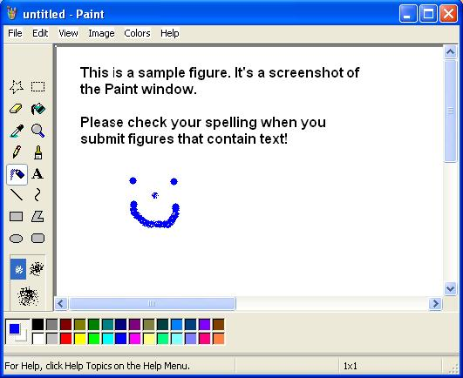
Figure 1.2 This is the figure caption, which uses the .Figure Caption style. Figure captions should be long and descriptive. Please use the caption to tell the reader all about the figure so that even if they aren’t reading the text they can understand what the figure is and what it’s showing.
The paragraph the figure itself comes in uses the .Figure style. Be sure to have some text after the figure, before the end of the section.
1.5 Creating tables
To create a table, you use Word’s table feature. First, enter your table’s caption. Then, choose Table > Insert Table and tell Word how many rows and columns you need.
Place references within your chapter text to refer your readers to the corresponding table. Table references look like this: table 1.1. Notice that unless the reference is at the beginning of a paragraph, the word “table” is lowercase.
Table 1.1 This table caption is written using the .Table Caption style. Table captions should be descriptive and as long as necessary to tell the reader what the table contains.
Table column head | Uses .Table Head style | Here’s one more
This is a table entry. * | Entries use the .Table Body style. | Table entry using .Code in Table style
This is another entry. | And here’s another. | One more with code text
* This is a table footnote, styled with the .Table Footer style.
Remember, a section can’t end with a table.
1.6 Miscellany
Occasionally you’ll need to include a quote from another source or format a sentence or two of text that so it’s pulled out from the regular paragraph. You can do so as follows:
This is a block quote, which uses the .Quote style. It’s a little bit smaller than regular text, and it’s indented from the left and right margins.
—Author or source, written with .Quote Source style, preceded by an em dash
Tip
To return any text to the formatting used by the rest of the paragraph—for instance, to undo .Code in Text or .Bold—select the text in question and click the Clear Font Formatting button on the Manning toolbar.
Sidebar head written with .Sidebar Head style
A sidebar (written with the .Sidebar style) is a side commentary on your chapter that’s too long to be a note and use the .Callout style. When the chapter is typeset, the sidebar will be set off in a box on the page. Every sidebar must have a heading. You should use sidebars sparingly and reserve them for text that is more than a paragraph long.
Use the .Typesetter Note paragraph style to “talk” to your typesetter—for example, to give placement instructions for an element on the page.
Because the Manning template is protected to avoid the accidental introduction of new styles, the standard Bold, Italic, and Underline buttons on the Formatting toolbar are disabled. To apply those types of formatting to text, please use the .Bold (shortcut: Ctrl+B), .Italics (Ctrl+I), .Bold Italics, and .Underline (Ctrl+U) styles available on the Manning toolbar. (To turn off these formats, press Ctrl+Space.) If you need any other types of formatting, please talk to your editor or insert a note to the typesetter.
If your chapter includes a list of references, use the .Reference style.
If your book includes a glossary, it uses two styles:
.Glossary Term
.Glossary Definition

This is a footnote, which is styled with .Footnote style. This footnote contains some code.

